MID OEL PROJECT REPORT

Department of Computer Science
Grocery Store Billing System (Java OOP)
Course: Object Oriented Programming Lab (OOP)
Submitted To: Miss Aimen (OOP Lab Instructor)
Submitted By: Mohsin Ali Mughal
Student ID: 74669

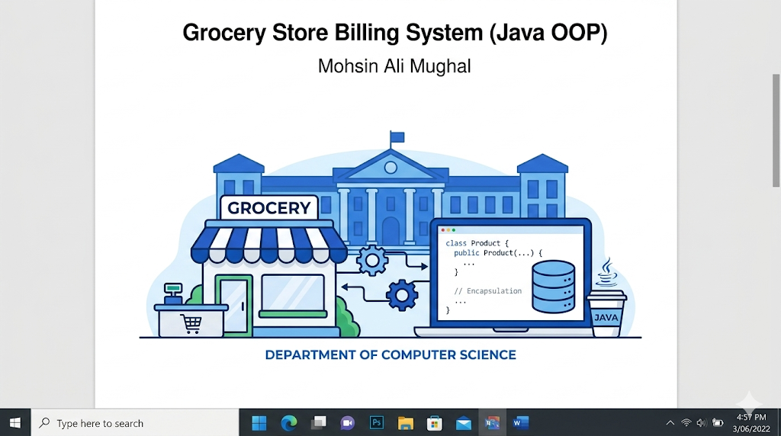

Acknowledgement:
I would like to thank my instructor for guiding me throughout this project. This assignment helped me understand how Object-Oriented Programming concepts can be applied in real-world problems. I also learned how to design a simple system using Java in a structured and organized way.

Abstract:
This project is a simple Grocery Store Billing System developed using Java programming language. The main purpose of this system is to automate the billing process and manage product inventory in a basic and efficient way.
The system allows the user to view available products, generate customer bills, and automatically update stock after each purchase. The project is developed using Object-Oriented Programming concepts such as classes, objects, and encapsulation.
This system is designed as a console-based application to keep it simple and easy to understand for learning purposes.

Introduction:
In small grocery stores, billing is often done manually which can lead to mistakes and slow processing. This project provides a simple computerized solution to handle billing operations.
The Grocery Store Billing System helps in:
- managing product data
- calculating customer bills
- updating inventory after sale
The system is implemented in Java and follows the Object-Oriented Programming approach, making the code organized and easy to maintain.

Objectives:
The main objectives of this project are:
- To create a simple billing system using Java
- To apply Object-Oriented Programming concepts
- To reduce errors in manual calculations
- To manage product inventory efficiently
- To generate accurate customer bills with tax

Project Scope:
This system is designed for small-level use and includes the following features:
- Display available products
- Select products using ID
- Enter quantity for purchase
- Calculate total bill
- Apply tax (5%)
- Update stock automatically
- Print final receipt
This project is limited to a console-based application and does not include database or graphical interface.

Tools and Technologies:
- Programming Language: Java
- Concept Used: Object-Oriented Programming (OOP)
- IDE: VS Code / NetBeans / IntelliJ IDEA
- Platform: Console-based application

OOP Concepts Used:

1. Class and Object
Classes like Product and BillingSystem are created. Objects are used to store product details and manage operations.

2. Encapsulation
Data members in the Product class are kept private and accessed using getter and setter methods. This protects the data and controls access.

3. Abstraction
The internal working of billing and inventory is hidden inside methods. The user only interacts with simple menu options.

4. Modularity
Different tasks like inventory display and billing are handled in separate methods, making the program organized.
System Modules:

1. Product Module
This module stores product information such as ID, name, price, and stock.

2. Inventory Module
This module displays available products and checks product availability during billing.

3. Billing Module
This module calculates the total bill, applies tax, and generates the receipt.

4. User Interface Module
This module handles user interaction using menu options in the console.

System Flow (Explanation):
The system works in the following steps:
- Program starts
- Default products are loaded
- Menu is displayed to user
- User selects an option
  - View inventory
  - Generate bill
  - Exit
- If billing is selected:
  - User enters product ID
  - User enters quantity
  - System checks stock
  - Total is calculated
- After finishing selection, bill is printed
- Program returns to menuFlowchart: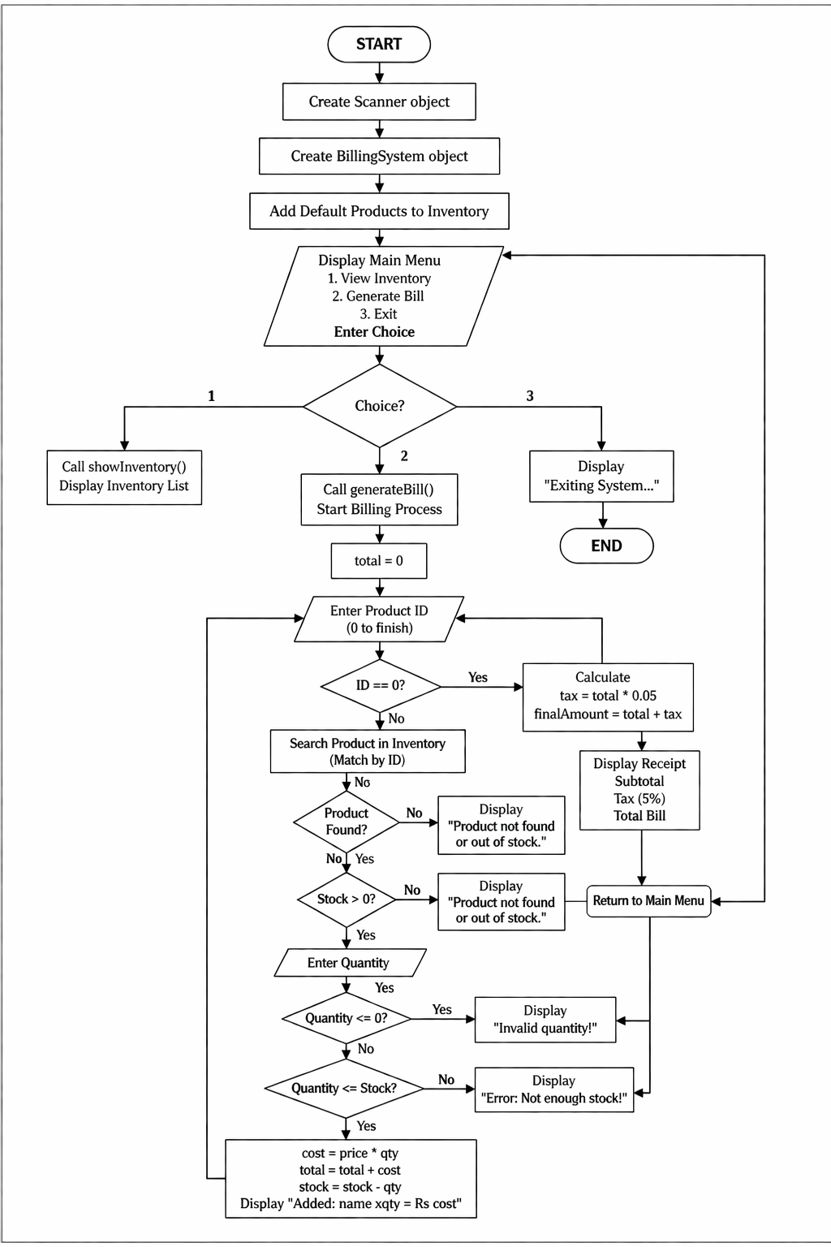

Sample Output:
Example:
--- Grocery Store Billing System ---
1. View Inventory
2. Generate Bill
3. Exit
--- Available Inventory ---
ID Name Price Stock
101 Milk 120.00 50
102 Bread 80.00 30
--- Start Billing ---
Enter Product ID: 101
Enter Quantity: 2
Added: Milk x2 = Rs 240
********** RECEIPT **********
Subtotal : Rs 240.00
Tax (5%) : Rs 12.00
Total Bill : Rs 252.00
*****************************

Advantages of the System:
- Simple and easy to use
- Reduces manual calculation errors
- Saves time during billing
- Organized code using OOP
- Easy to expand in future

Limitations:
- No database (data is not saved permanently)
- No graphical user interface
- Limited features (basic system only)
- No user login system

Future Enhancements:
In future, this system can be improved by adding:
- GUI using Java Swing
- Database connectivity (MySQL)
- User login system
- Product categories
- Discount system
- File saving for records

Conclusion:
This project helped in understanding how Object-Oriented Programming concepts are used in real applications. The Grocery Store Billing System successfully performs basic billing and inventory tasks in a simple and efficient way.
It is a good example of how programming can be used to solve real-world problems in a structured manner.
Source Code:
import java.util.ArrayList;
import java.util.Scanner;
// Product Class (Encapsulation)
class Product {
private int id;
private String name;
private double price;
private int stock;

public Product(int id, String name, double price, int stock) {
this.id = id;
this.name = name;
this.price = price;
this.stock = stock;
}
public int getId() { return id; }
public String getName() { return name; }
public double getPrice() { return price; }
public int getStock() { return stock; }

public void setStock(int stock) {
this.stock = stock;
}
}

// Billing and Inventory Module
class BillingSystem {
private ArrayList<Product> inventory = new ArrayList<>();
private Scanner scanner;

public BillingSystem(Scanner scanner) {
this.scanner = scanner;
}

public void addDefaultProducts() {
inventory.add(new Product(101, "Milk", 120.0, 50));
inventory.add(new Product(102, "Bread", 80.0, 30));
inventory.add(new Product(103, "Eggs", 15.0, 100));
}

public void showInventory() {
System.out.println("\n--- Available Inventory ---");
System.out.printf("%-10s %-15s %-10s %-10s%n", "ID", "Name", "Price", "Stock");
for (Product p : inventory) {
System.out.printf("%-10d %-15s %-10.2f %-10d%n",
p.getId(), p.getName(), p.getPrice(), p.getStock());
}
}

public void generateBill() {
double total = 0;
System.out.println("\n--- Start Billing ---");

while (true) {
System.out.print("Enter Product ID to buy (or 0 to finish): ");
int id = scanner.nextInt();

if (id == 0) {
break;
}

Product found = null;
for (Product p : inventory) {
if (p.getId() == id) {
found = p;
break;
}
}

if (found != null && found.getStock() > 0) {
System.out.print("Enter Quantity: ");
int qty = scanner.nextInt();

if (qty <= 0) {
System.out.println("Invalid quantity!");
continue;
}

if (qty <= found.getStock()) {
double cost = found.getPrice() * qty;
total += cost;
found.setStock(found.getStock() - qty);
System.out.println("Added: " + found.getName() + " x" + qty + " = Rs " + cost);
} else {
System.out.println("Error: Not enough stock!");
}
} else {
System.out.println("Product not found or out of stock.");
}
}

double tax = total * 0.05;
double finalAmount = total + tax;

System.out.println("\n********** RECEIPT **********");
System.out.printf("Subtotal : Rs %.2f%n", total);
System.out.printf("Tax (5%%) : Rs %.2f%n", tax);
System.out.printf("Total Bill : Rs %.2f%n", finalAmount);
System.out.println("*****************************");
}
}

// Main Class
public class Main {
public static void main(String[] args) {
Scanner input = new Scanner(System.in);
BillingSystem store = new BillingSystem(input);
store.addDefaultProducts();

while (true) {
System.out.println("\n--- Grocery Store Billing System ---");
System.out.println("1. View Inventory");
System.out.println("2. Generate Bill");
System.out.println("3. Exit");
System.out.print("Select an option: ");

int choice = input.nextInt();

if (choice == 1) {
store.showInventory();
} else if (choice == 2) {
store.generateBill();
} else if (choice == 3) {
System.out.println("Exiting System...");
break;
} else {
System.out.println("Invalid Choice!");
}
}

input.close();
}
}

Output screenshot:
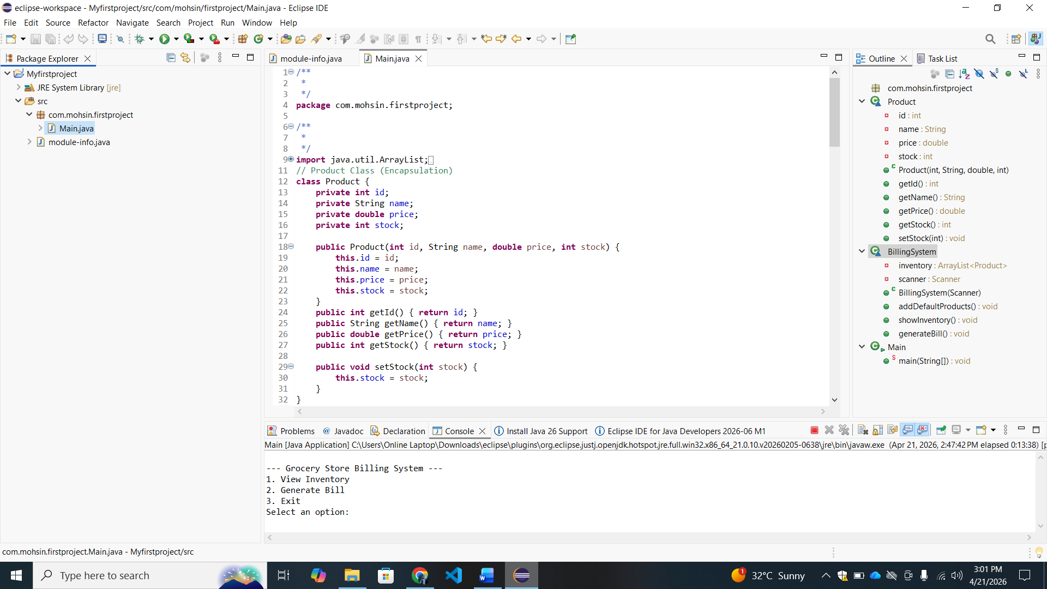

GitHub Repository:
The complete source code of this project is available on GitHub for easy access and review.
Repository Link:
https://github.com/mohsinalimughal/Grocery-Store-Billing-System-Java
This repository contains all project files including source code, report, and flowchart. It helps in maintaining version control and sharing the project easily.

